Procedure I ‐ Net Photosynthesis Rates ‐ 100% Illumination

Sun-Adapted Leaf Trial
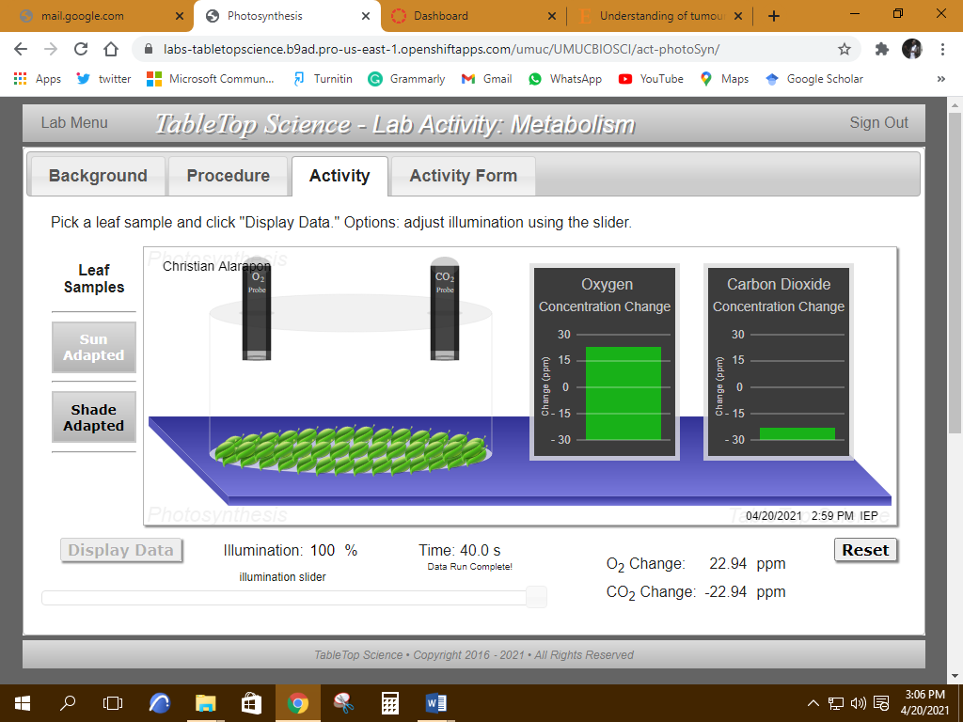

Shade-Adapted Leaf Trial

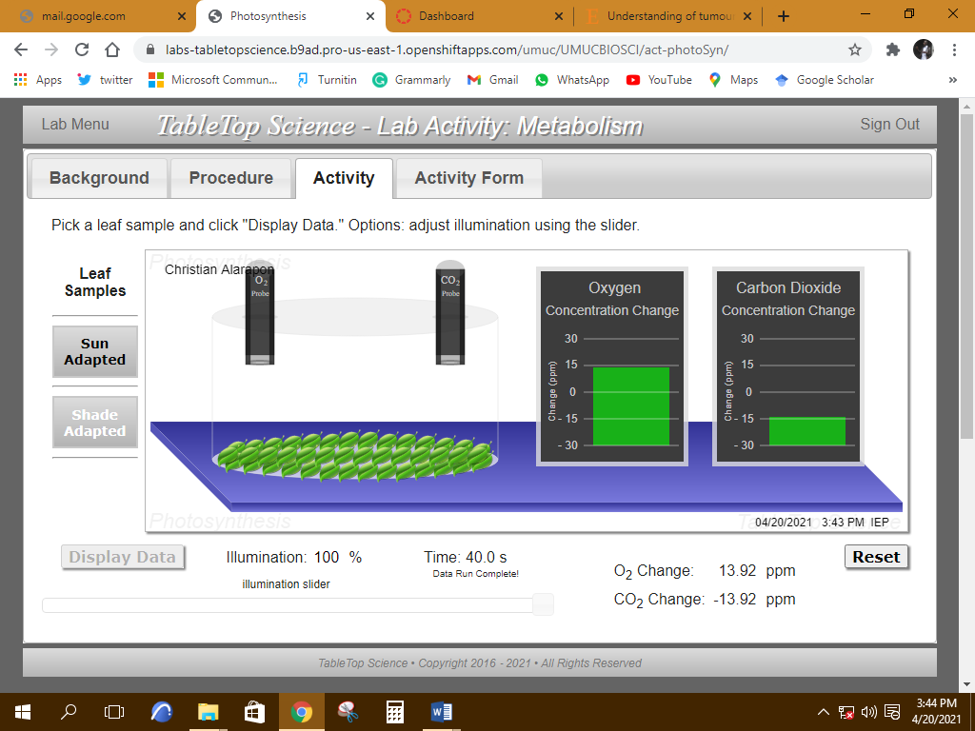

Procedure II ‐ Respiration Rates ‐ 0% Illumination

Sun-Adapted Leaf Trial
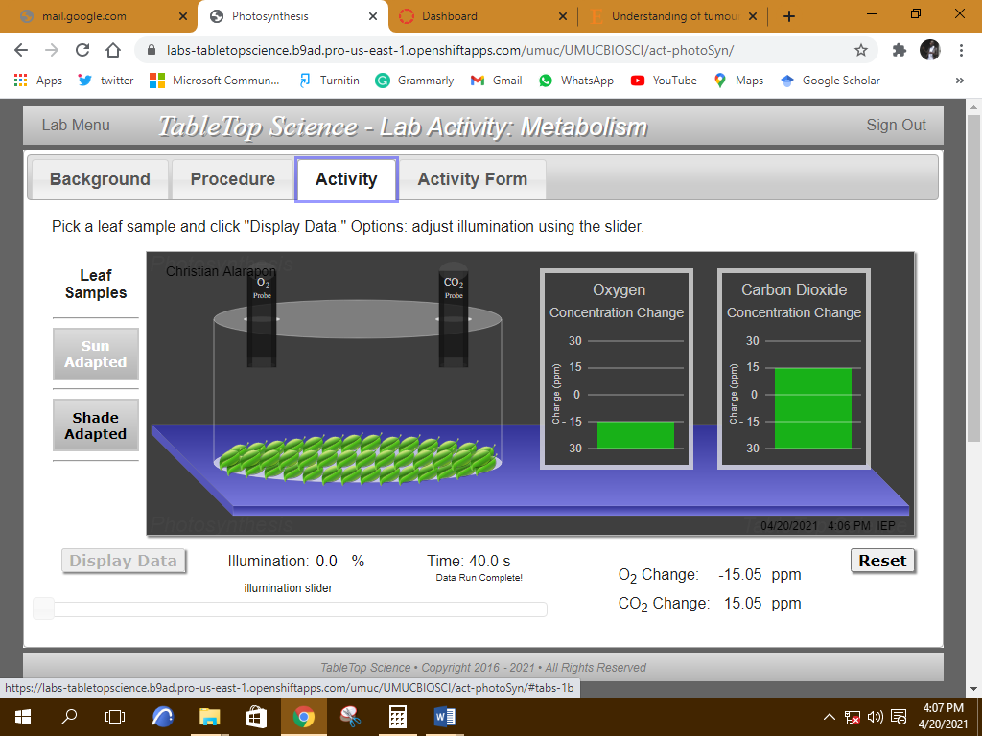

Shade-Adapted Leaf Trial
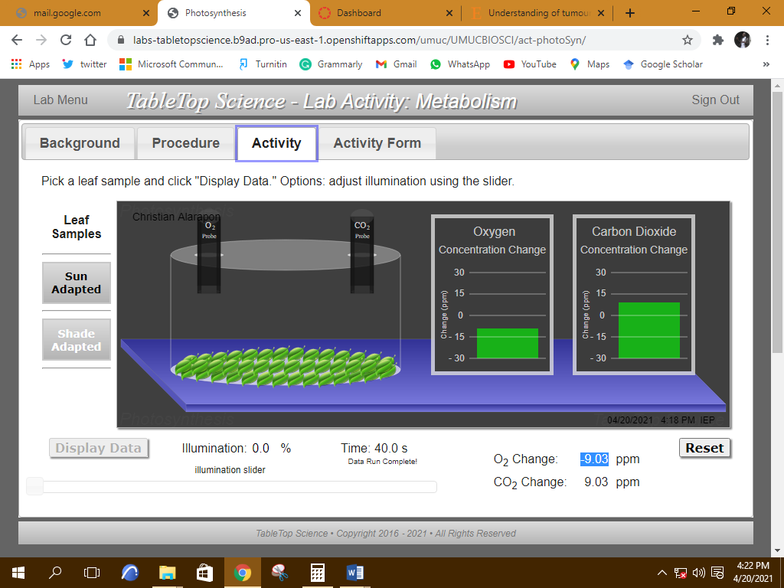

Procedure III ‐ Low-Light Net Photosynthesis Rates ‐ 15% Illumination
Sun-Adapted Leaf Trial
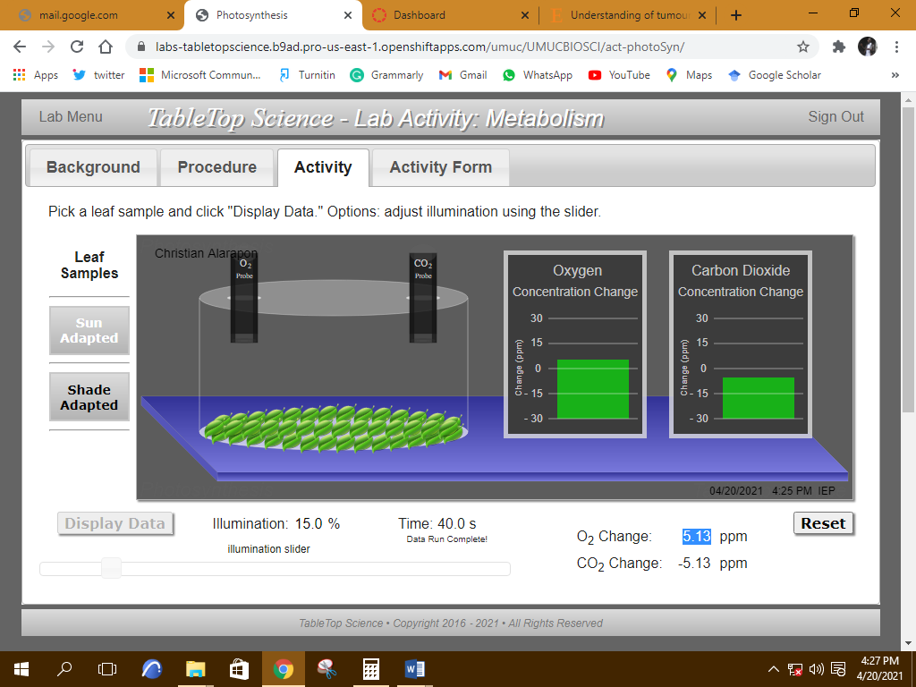

Shade-Adapted Leaf Trial
